Kyle Rayner

ksrayner@deakin.edu.au

Abstract

This document outlines and showcases the cycling with friends and against your ghost feature for the Smart Bike being developed by Redback Operations.

Feature Proposal Document

SIT374 – Team Project (A) – Project Management and Practices

Contents

Introduction 2

Overview of Proposed Feature 2

Mobile Application 2

Game-Oriented Solution 3

Development of the Feature 4

Conclusion 4

References 4

# Introduction

This document will present my idea for a feature that could be added to the Smart Bike project to increase engagement and motivation. I will refer to the feature I propose as the Competition Feature. I have provided a brief description of my overall idea which is then followed by how it could be implemented on both a mobile application and as a more game-oriented solution designed for traditional consoles, PC’s and Virtual Reality.

# Overview of Proposed Feature

The Competition Feature’s main functionality is being able to play against friends and also against your personal best time which is sometimes referred to as your ghost in racing games such as Trackmania. The Smart Bike will be able to accumulate data on speed, cadence, power and heart rate. Therefore, there are a number of variables that can be used to compare your efforts against your friends and/or your ghost in a multitude of ways. I think what would work best is to have courses/tracks that you can complete and compete against your friends/ghost on. This could be tracks similar to racing games or even just distance milestones like 10 kilometres and 20 kilometres. I have provided more information on the specific functionalities and some early designs of what it could look like for both the mobile app and the game solution in the following sections.

# Mobile Application

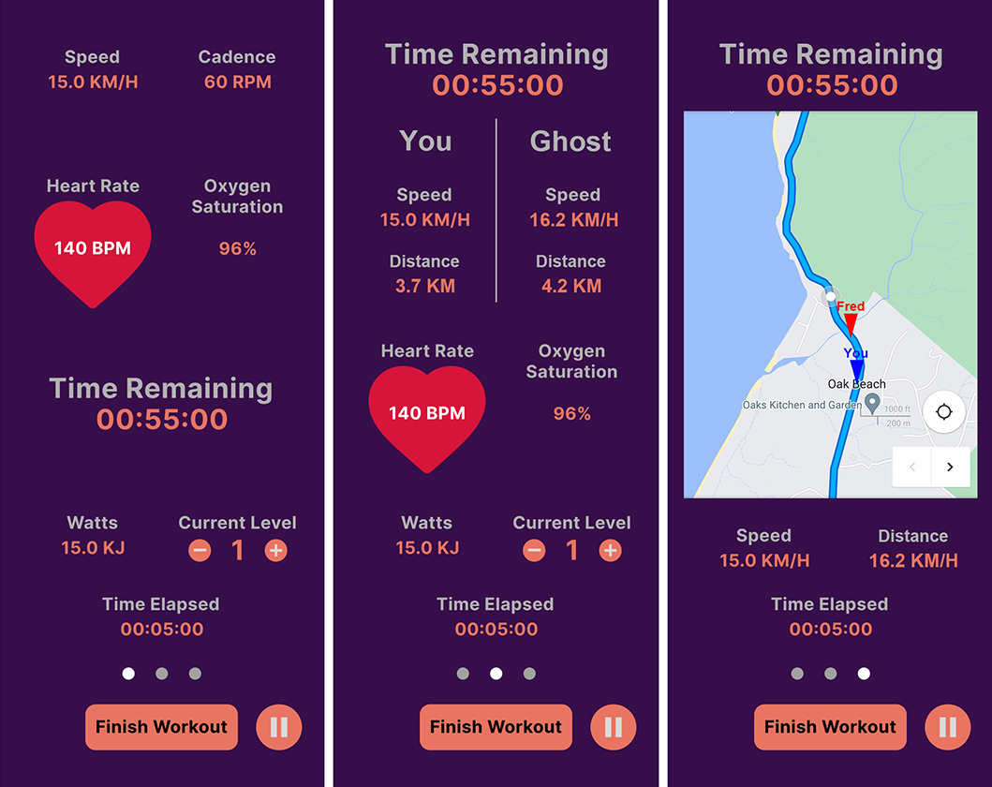

Figure – Left image is from the current designs, the middle and right image is my work showcasing my ideas

The images above showcase some early designs of what the mobile app might look like. I have designed each of these mock-ups with the intention of it fitting in with what the Mobile App Development team has done so far. The image on the left is from the current designs of the mobile app with a few changes. The most noticeable change is the three circles just above the ‘Finish Workout’ button. The idea is that if you are competing against your friend or your ghost, you can change between the three interfaces by swiping left and right. The middle image showcases what it might look like competing against your friend or ghost in a text-oriented way. Several statistics for your friend/ghost and yourself are displayed such as current speed and distance and possibly others as well. The purpose of this interface is to give yourself an overview of how you are doing compared to your friend/ghost. The image on the right is a more visual representation of the middle image. As mentioned above, there could be tracks/circuits that the user and their friends can cycle on. This would be presented in a way that is similar to Google Maps and indicators for both your friend/ghost and yourself are shown.

The Figma prototype of the mobile app also includes an interface for when the user finishes a workout which displays some useful information. If the user does compete against a friend or ghost, information regarding how the user stacks up against them would also need to be included in some way when the user finishes a workout.

# Game-Oriented Solution

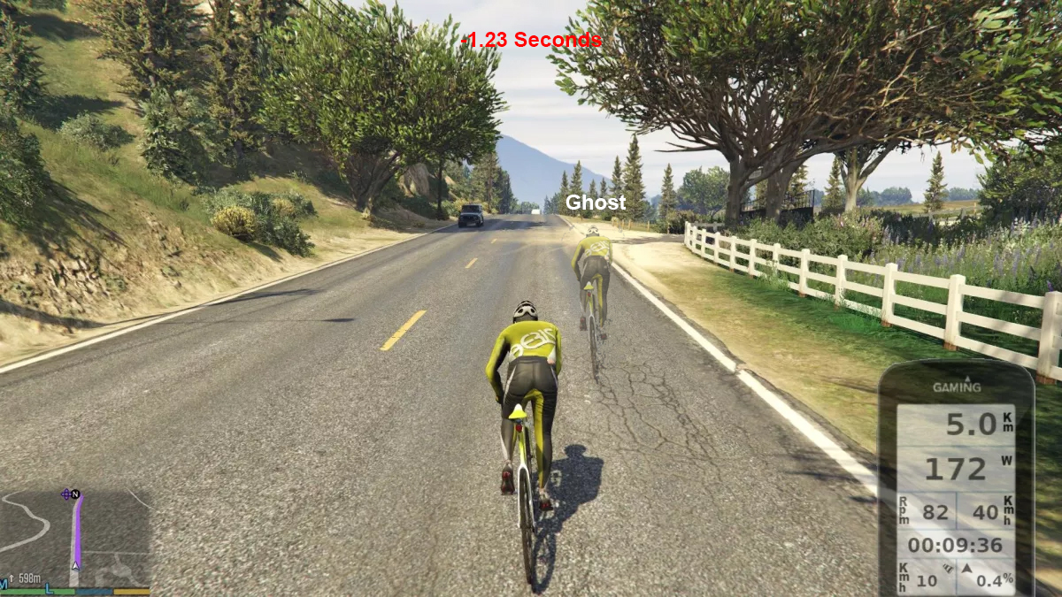

Figure 2 – Screenshot of the Grand Theft Auto 5 game captured by Bains (2022) and edited by myself

The image above showcases the Competitive Feature in a game solution possibly for PC or current generation consoles and possibly even for Virtual Reality with some changes to the perspective of the camera. This is pretty much the equivalence of the mobile app feature showcased above except that it is intended to be a 3D game with similarities to racing games like Trackmania or Gran Turismo. The main ideas I want to highlight are the following: When you are competing against a friend or ghost, it should be clear how you stack up against them. In this case, I have added some red text showcasing that the user is -1.23 seconds behind the ghost. This text would show up periodically (after every minute or kilometre) and when the user passes checkpoints on the map or course. I also added in the ghost cyclist which would be either the user’s best time or could be replaced with a friend. The screenshot below is from Grand Theft Auto 5 to help visualize my ideas. Both the smart phone and map shown in the image is the work of the game developers of Grand Theft Auto 5. However, I imagine we would showcase the user’s speed, distance, cadence and other such statistics in some way. This would also extend to when the user finishes the workout and would consequently showcase the friend/ghost’s results as well as the user’s results.

# Development of the Feature

This feature would require a decent amount of work from several teams depending on scope. This will largely depend on if we are developing the feature for the mobile application and/or the game solution for PC or Virtual Reality. Some of the teams that might need to be involved in the development of this feature include the IoT and Embedded Systems team, the Design team, the Mobile App Development team, the VR Modelling and Game Development team and possibly other teams as well. I have compiled a list of tasks that would likely need to be completed to get this feature up and running below. The task list is not an exhaustive list but more an indication of what needs to be done.

|  |  |
| --- | --- |
| **Task** | **Description** |
| Design user interface and interactions | I have provided some early mock-ups of what the user interfaces could look like for both the mobile app and game solution above. However, more time will need to be dedicated to refining my early mock-ups and also to create several other interfaces. The interactions that the user can perform will also need to be well thought out to provide a great user experience. |
| Obtaining data from the Smart Bike | From my understanding, a lot of work this trimester will be focusing on retrieving data from the Smart Bike. This will be crucial in developing the proposed feature. |
| Implementing the feature on the mobile app | The feature proposed will require the Mobile App Development team to set aside resources to develop this feature. With the mock-ups I created above, I tried to keep a consistent design with what the Mobile App Development team has done so far so hopefully it can seamlessly fit in with their solution. |
| Implementing the feature in a game solution | As per the previous task, a decent amount of work would be required to implement this feature. I believe the VR Modelling and Game Development team are working on several projects. It is possible that the Competitive Feature might work well within one of their existing projects. |

# Conclusion

I have described my proposed feature and what exactly it entails. I have also provided initial designs for both a mobile app and a 3D game. Finally, I given some thought as to the work that needs to be done and outlined some tasks that would help get this feature to a working state.

# References

Bains C (2022) You can now pedal around GTA 5 using real-life smart bike, TechRadar, accessed 29 July 2022. <https://www.techradar.com/news/you-can-now-pedal-around-gta-5-using-a-real-life-smart-bike>

Rockstar North (2013) Grand Theft Auto V, Computer Program, Edinburgh, Scotland